Іванов Кирил  
ФІТ 2-8

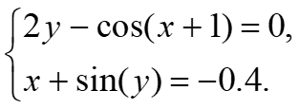

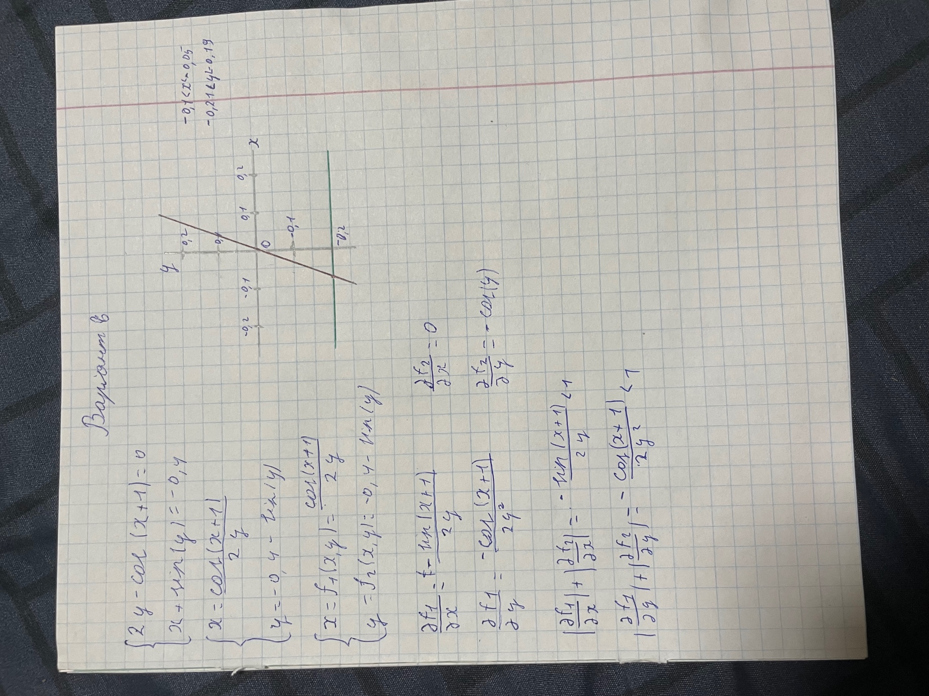

Код

import math

x0 = 0.1

y0 = -0.2

delta = 0.001

def f1(x, y):

return math.cos(x + 1) / (2 * y)

def f2(y):

return -0.4 - math.sin(y)

x = -0.075

y = -0.2

epsilon = 0.001

while True:

x_new = f1(x, y)

y_new = f2(y)

if abs(x_new - x) < epsilon and abs(y_new - y) < epsilon:

break

x, y = x_new, y_new

print("Розв'язок:")

print(f"x = {x}")

print(f"y = {y}")

